Ajinomoto Philippines – QC Receiving, LIMS, Rejections & RTV Requirements
Workshop, 28 Oct (morning) · Oct 28, 2026 · @Srini

1. Workshop context and scope
This session confirmed that the planned LIMS covers laboratory testing only. Receiving inspection, non-conformance reports and returns to vendor stay outside it, so the new platform must capture them some other way to give suppliers and scorecards a full quality picture.
Item | Detail
Client | Ajinomoto Philippines Corporation (APC), Project Beacon
Session | Agenda Session 3 – LIMS and QC receiving (morning part), 28 Oct 2026
Durvah team | Kishore, Sunit Nighut
Ajinomoto | Chris Ballesteros (Beacon lead); QC receiving; QC laboratory and LIMS project team; RM/PM warehouse manager (WMS user); supply planning; procurement; IT
In scope today | QC receiving inspection, lab testing and LIMS scope, quality release, outright and partial rejection, NCR and CAR, return to vendor (RTV), claim and credit notes, production returns
Deferred to afternoon | Supplier allocation, delivery assignment and commitment, supplier collaboration
Related documents: Session 2 (planning, PR–PO, ASN and GR) and Session 3 (invoicing, DOA and supplier performance).

2. Current process (as-is)
Quality decisions are made in WMS by unchecking a hold, while every report, claim and return is handled by email and paper. SAP records only stock adjustments, without any link to the PO.
A. Receiving and inspection (RM/PM warehouse, Infor WMS)
- The delivery arrives at the receiving area. Receivers key in batch/lot number, manufacturing date and expiry date in WMS, then scan the goods in.
- The WMS barcode is an internal location/pallet code used for location management only. The WMS “ASN” number is an internal transaction number linked to the PO, not a supplier notice.
- QC receiving inspects the delivery for damage, dirt, insects and foreign material against standards. Accepted quantity is received. GR posts to SAP and stock stays on hold until QC release.
B. Laboratory testing (LIMS planned)
- Every new supplier batch is sampled and sent to the QC laboratory. A batch already tested from the same supplier is not retested.
- Today, results are recorded outside any system.
- The planned LIMS will:
  - manage samples from receipt to release of the certificate of analysis (COA);
  - take results directly from three instruments (including a spectrometer and a water activity meter);
  - receive sample and batch details from WMS and send the pass/fail result back to WMS for release;
  - cover RM/PM and FG testing.
- The LIMS team confirmed scope: laboratory testing only, about five users, with access tightly controlled. Receiving inspection is out of scope, though the team said it may consider it. LIMS issues COAs, not NC reports. LIMS traceability currently goes to batch level only.
- Cebu follows the same process.
C. Quality release
- QC releases stock in WMS by searching the batch and removing the hold, then printing a slip. No QC report or result is attached in any system.
D. Rejections
Scenario | What happens today
Partial outright reject at delivery (e.g. 10 of 1,000 bags damaged) | Rejected quantity backloaded on the truck immediately. Local: only the accepted quantity (990) is received. Import: full quantity received, rejected quantity moved to restricted location pending documents.
Whole shipment outright rejected (local, mainly PM) | No GR is made. The system never learns the PO line was delivered and rejected. The line stays open and may be reused for a later delivery. NC counted manually.
Lab test fails after receipt | Local supplier: return to vendor. Import: usually disposed. Claim memo or debit note issued; supplier sends credit note.
Defect found in production after consumption | Returned to supplier physically; claimed by claim memo and credit note. No system transaction.
New supplier or new material, first delivery | Extra tests (e.g. sensory) outside the system. Results go into the sourcing evaluation.
E. Non-conformance and corrective action
- QC receiving (or the lab, via QC receiving) prepares the NC report manually and emails it to procurement and the departments involved.
- Procurement forwards it to the supplier. A CAR is required when the NC is critical, or when non-critical NCs exceed the threshold. Below the threshold, no CAR is needed but the NC still counts in supplier performance.
- Outstanding RTVs and claims are tracked monthly in Excel. All RTVs must be cleared before the annual inventory count.
F. SAP postings for rejections and returns
- Returns are not posted with SAP's standard return-to-vendor (movement type 122 against the PO). Stock is reduced by custom inventory adjustment movements (Z19 / Z20) or scrapping, without a PO reference.
- So SAP still shows the full quantity as received against the PO. Finance cannot see that a debit note is due, and the supplier may invoice the full quantity. Credit and debit notes are raised manually.
G. Issue to production (context)
- Production planning raises a shipment order in WMS. The warehouse picks and ships out to the plant, and WMS removes the stock. The finished goods receipt step in WMS is still to be confirmed.

3. As-is process flow
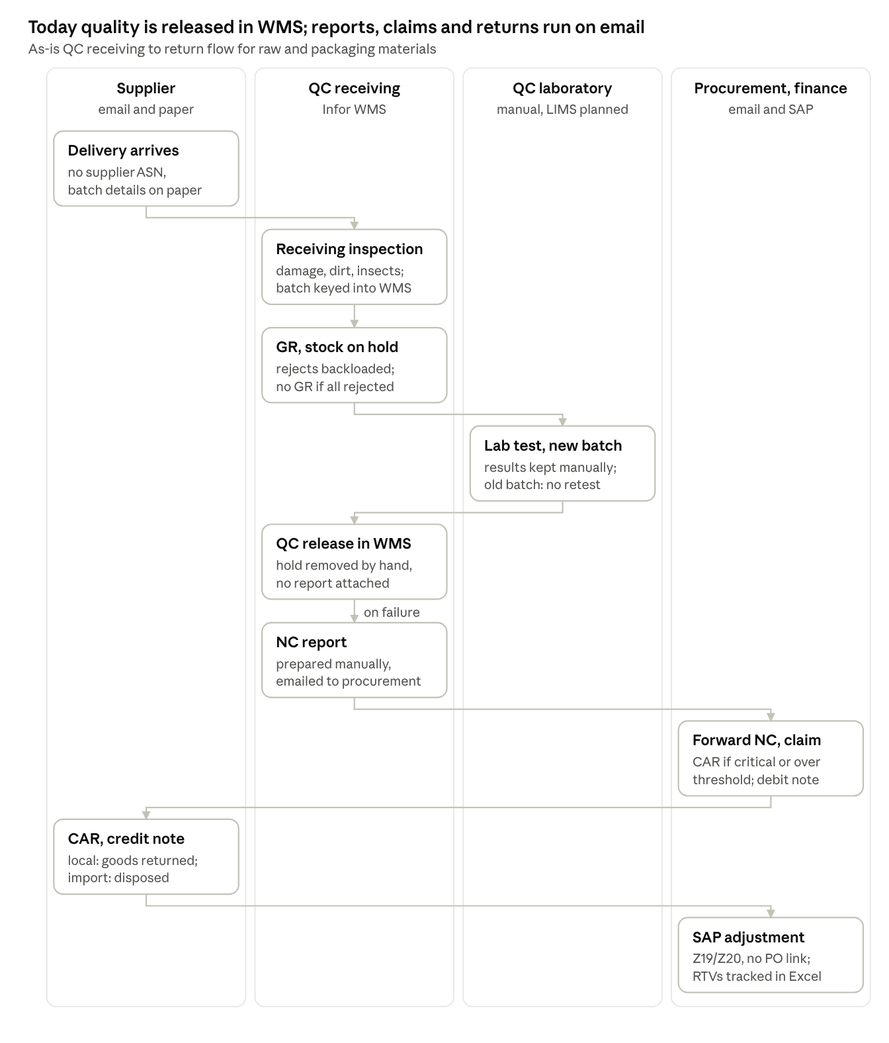
As-is QC receiving to return · 4 lanes, 9 steps
The flow loses its link to the PO twice: when a whole shipment is rejected without a GR, and when the return is posted as a stock adjustment.

4. Pain areas
The central gap is traceability: when one PO line is delivered several times and one lot fails, no system can say which delivery, batch or supplier lot it was.
# | Pain area | Impact
P1 | Lab results and receiving inspection results held outside any system | No traceable quality record per delivery
P2 | No link from a failed result to the specific ASN, GR and supplier batch when one PO line has several receipts | Supplier cannot be told which shipment failed; disputes
P3 | NC reports prepared manually and sent by email; not attached in WMS or LIMS | Slow CAR cycle; no history; NC count kept by hand
P4 | LIMS will cover lab testing only and will not issue NCs | Receiving-inspection NCs (damage, dirt, insects, foreign matter) still have no system home
P5 | Whole-shipment outright rejection of local deliveries has no GR | Delivery invisible in the system; PO line stays open and is reused; on-time and NC metrics wrong
P6 | Returns posted as inventory adjustments (Z19/Z20, scrapping) without PO reference | SAP shows full receipt; supplier may invoice full quantity; debit note not triggered
P7 | Claim memos, debit notes and credit notes raised and tracked manually | Slow recovery of money; outstanding RTVs tracked monthly in Excel
P8 | Production-found defects after consumption have no transaction | Returns and claims not recorded; supplier performance understated
P9 | Treatment of rejected PO lines (replacement delivery or reuse of line) is not standard between RM and PM | Inconsistent scoring and open-PO data
P10 | QC release is a manual uncheck in WMS with a printed slip | No audit trail of who released what and why

5. To-be process
In the target design, every inspection result, lab failure and rejection is recorded against its PO line, ASN, GR and batch. The NC, CAR, claim and credit note then run through the supplier portal, and returns post in SAP against the PO.
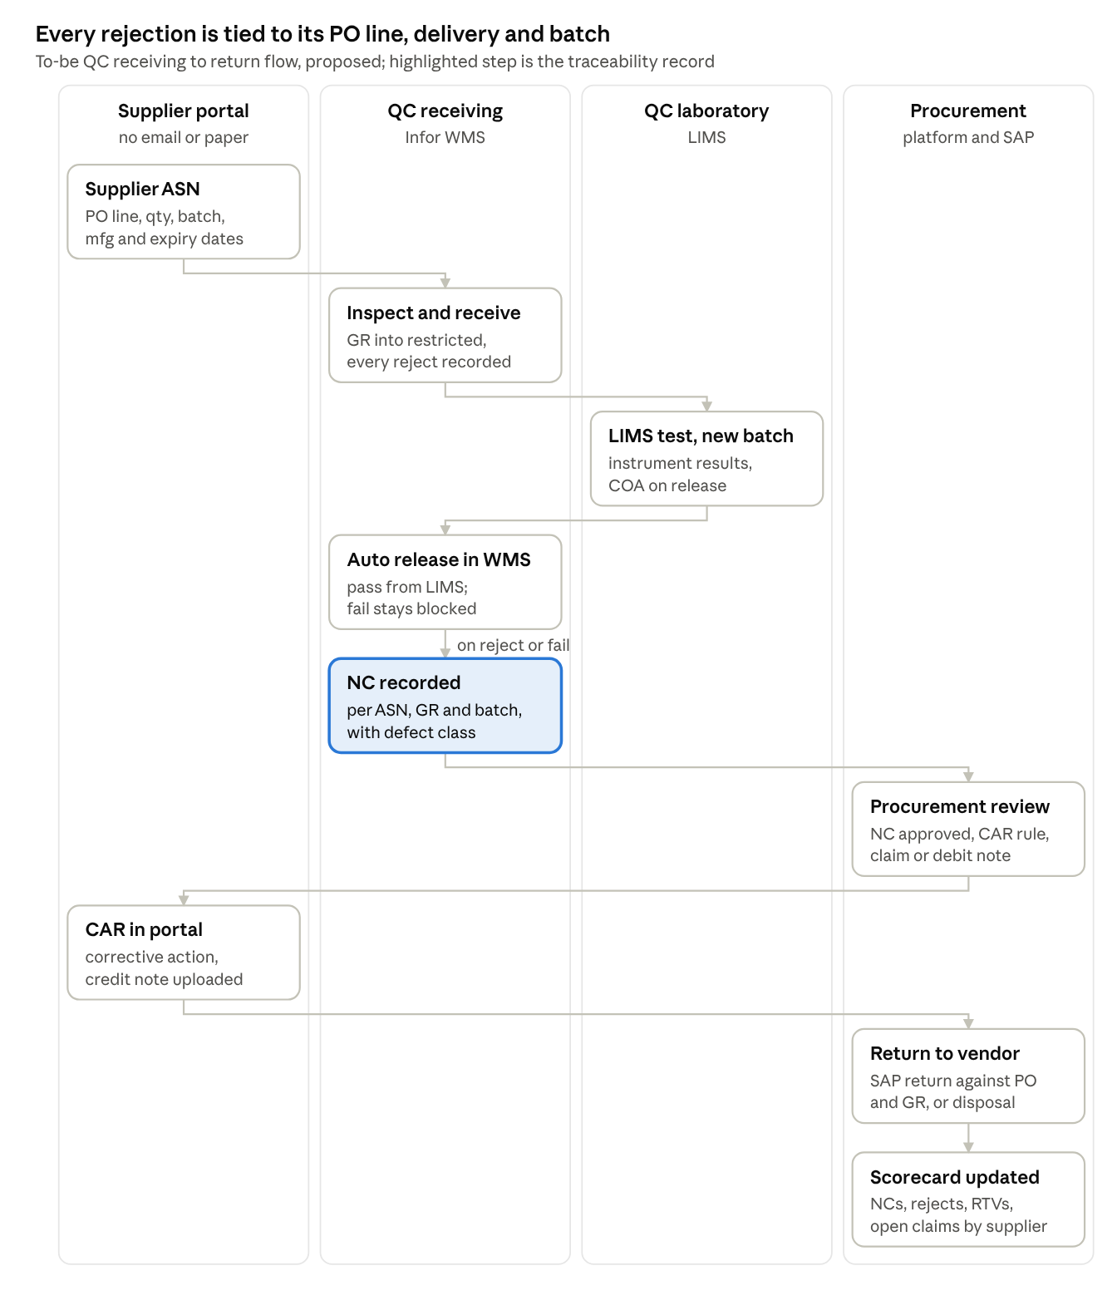
To-be QC receiving to return · 4 lanes, 9 steps
What changes:
- Batch data: comes in on the supplier ASN, so receivers stop keying it.
- Outright rejections: even a whole-shipment reject is recorded against the PO line (proposed: GR into restricted stock), so the delivery and the NC are visible.
- Release: LIMS sends pass/fail per batch to WMS, which releases or blocks stock automatically. The platform shows the result per GR line to the supplier.
- NC creation: NCs are created in the system, not by email. Where they are created (WMS, LIMS or the platform) is still to be decided.
- Supplier response: procurement approves the NC before the supplier sees it. CAR rules (critical, or over threshold) apply automatically, and the CAR and credit note come back through the portal.
- Returns: RTVs use SAP's standard return against PO and GR, so finance can see what should not be paid and outstanding claims show on a dashboard.

6. Functional requirements
Sixteen requirements came out of this session. Priorities are Durvah's proposal for Ajinomoto to confirm.
ID | Area | Requirement | Priority
QC-01 | Supplier batch data | Supplier ASN carries batch/lot, manufacturing and expiry dates per PO line, so WMS receives them without re-keying (links to Session 2 PP-10) | Must
QC-02 | Receipt traceability | Each receipt identifiable by PO line, ASN, GR document and supplier batch, through WMS, SAP and LIMS | Must
QC-03 | Receiving inspection result | Record receiving inspection outcome (accepted, partially rejected, outright rejected) with quantity and defect type in WMS or the platform | Must
QC-04 | Outright rejection | Even fully rejected deliveries are recorded against the PO line (e.g. GR into restricted or blocked stock, or a rejection record) so the delivery and NC are visible | Must
QC-05 | Lab result interface | LIMS pass/fail per batch sent to WMS for automatic release or block, and summarised to the platform per GR line for the supplier | Must
QC-06 | COA | COA from LIMS (and supplier COA where applicable) linked to the batch and visible to procurement | Should
QC-07 | NC creation | NC report created in the system for receiving, lab and production defects, with NC type, defect class (critical / non-critical), quantity, PO line, ASN, GR and batch | Must
QC-08 | NC review and release | Procurement reviews and approves the NC before it is released to the supplier in the portal | Must
QC-09 | CAR rules | CAR required automatically for critical NCs or when non-critical NCs exceed the threshold; otherwise NC is recorded for performance only | Must
QC-10 | CAR tracking | Supplier submits the CAR in the portal; APC records verification over the next three deliveries and closes the NC (links to Session 2 PP-14) | Must
QC-11 | Return to vendor | Returns posted in SAP against the PO and GR (standard return delivery) instead of inventory adjustments, from WMS or the platform | Must
QC-12 | Disposal | Imported rejects that are disposed are recorded against the PO and GR with the claim | Must
QC-13 | Claims and notes | Claim memo or debit note issued to the supplier in the portal; supplier uploads the credit note; status visible to finance and the warehouse | Must
QC-14 | RTV monitoring | Dashboard of outstanding RTVs, claims and credit notes by supplier and age, so all are cleared before the annual inventory count | Should
QC-15 | Production defects | Production-found defects can be recorded as NCs and returns against the original batch and GR | Should
QC-16 | Quality performance | NC counts by class, rejections, outright rejects and RTVs per supplier feed the supplier scorecard (links to Session 3 SP-01) | Must

7. Open questions
# | Question | For
Q1 | Where should NC reports be created: WMS, LIMS (if extended), a separate QMS, or the procurement platform? | APC QC, IT, Durvah
Q2 | Can LIMS carry the WMS ASN or GR reference with each sample, not only the batch? | LIMS team and vendor
Q3 | Can Infor WMS record receiving-inspection results and NC data, and send them by interface? | IT, warehouse, Infor vendor
Q4 | Will whole-shipment outright rejections of local deliveries be received into restricted stock so the PO line records the delivery? | Warehouse, procurement, finance
Q5 | After an outright rejection, is the PO line closed, reused or replaced? Should RM and PM follow the same rule? | Procurement, planning
Q6 | Why was standard return-to-vendor (122) not used in SAP, and can it be enabled with WMS? | IT (SAP team), finance
Q7 | What are the NC threshold values and the definitions of critical and non-critical? | QC (NC guideline)
Q8 | When will LIMS go live, and will the platform integrate with LIMS directly or through WMS? | LIMS team, IT
Q9 | How are FG receipts and production returns recorded in WMS? | Warehouse (follow-up)

8. Action items
Nine actions came out of this session. Deciding where NCs are created (A1) and agreeing the outright-reject rule (A4) unblock the to-be design. Owners are proposed from the discussion; please confirm.
# | Action | Owner | Due | Status
A1 | Recommend where NC reports are created and how they reach the platform (WMS, LIMS, QMS or platform) | Durvah (Kishore, Sunit) | With requirements pack | Open
A2 | Confirm whether LIMS can store ASN or GR references with samples, and whether receiving inspection can be added to LIMS scope | LIMS team with vendor | Next week | Open
A3 | Check Infor WMS ability to record inspection results and NCs and to interface them | IT with Infor vendor | Next week | Open
A4 | Agree a standard rule for outright rejections (GR into restricted stock; PO line closure or replacement) for RM and PM | Warehouse, procurement, finance | Before design | Open
A5 | Review enabling SAP return to vendor (122) against PO and GR in place of Z19/Z20 adjustments | IT (SAP team), finance | Next week | Open
A6 | Share the NC report, CAR, claim memo and debit note templates and the NC guideline (thresholds, critical definitions) | QC receiving, procurement | This week | Open
A7 | Share the monthly RTV and claims monitoring file | Procurement / warehouse | This week | Open
A8 | Confirm FG receipt and production return transactions in WMS | RM/PM warehouse manager | Next session | Open
A9 | Hold the deferred session on supplier allocation, delivery assignment and commitment, and collaboration | Procurement, planning, Durvah | 28 Oct afternoon | Open

